CLOUD COMPUTING LAB EXAM

Submitted By: Zunaira Khatoon
Submitted To: Engr. Muhammad Shoaib
Roll No: BSE-2023-074
Section: V-B

Q1 – AWS IAM Setup Using AWS CLI and Console Verification (10 marks)
- Create IAM group SoftwareEngineering using AWS CLI
Use the AWS CLI to create an IAM group named SoftwareEngineering.
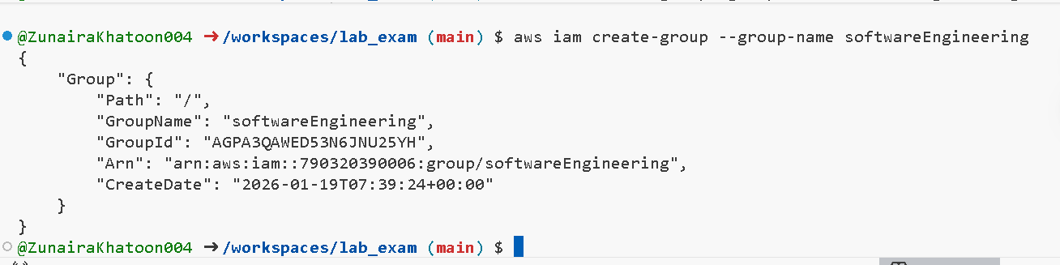
- Then use the AWS CLI to view the group details.
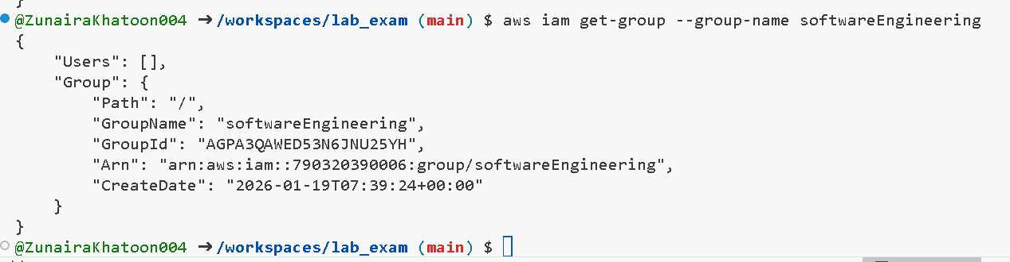

- Create IAM user (your name) and view details
Using the AWS CLI, create an IAM user whose username is based on your own name (for example, Ali, Sara, YOURNAME).
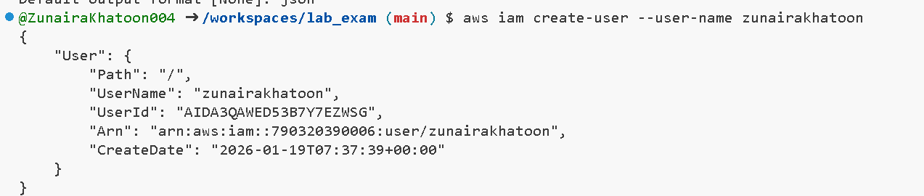
Use the AWS CLI to view the user details.
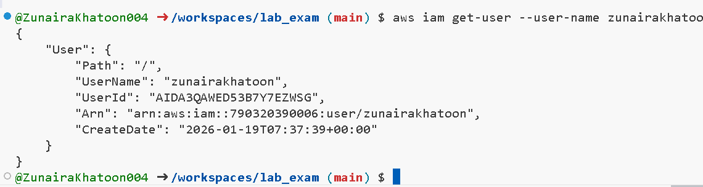
- Add the IAM user to the SoftwareEngineering group
Using the AWS CLI, add the IAM user (created above) to the SoftwareEngineering group.
se the AWS CLI to view the group membership and confirm your user is a member.
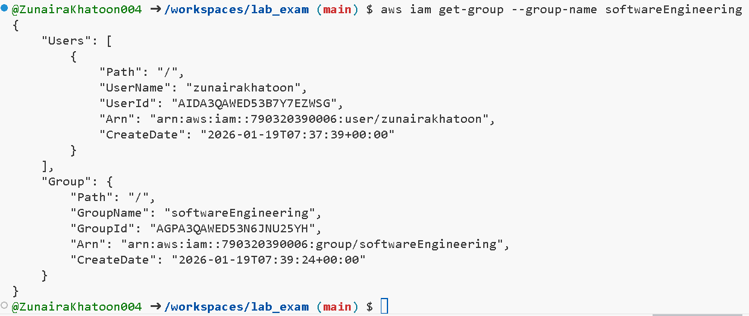
- Attach AdministratorAccess managed policy to the SoftwareEngineering group
Using the AWS CLI, locate and identify the AWS managed policy named AdministratorAccess, including its ARN
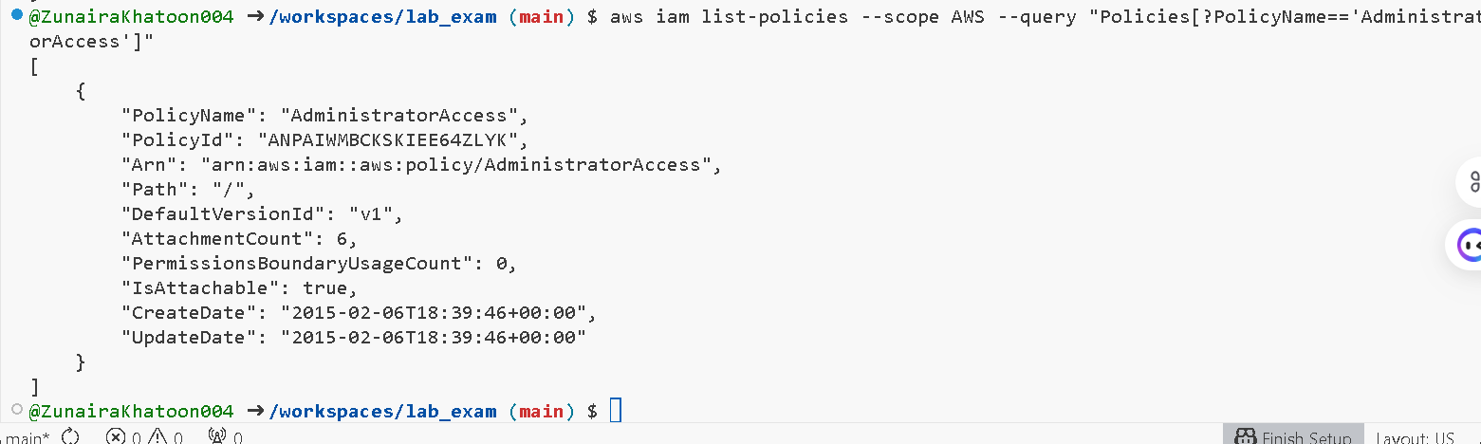

Using the AWS CLI, attach the AdministratorAccess managed policy to the SoftwareEngineering group using its policy ARN.
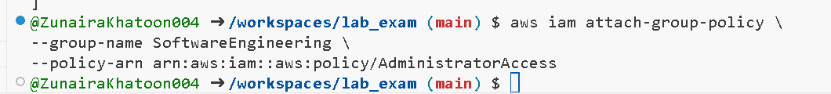

- List attached policies of the SoftwareEngineering group
Using the AWS CLI, list the policies attached to the SoftwareEngineering group
(for example, list-attached-group-policies).

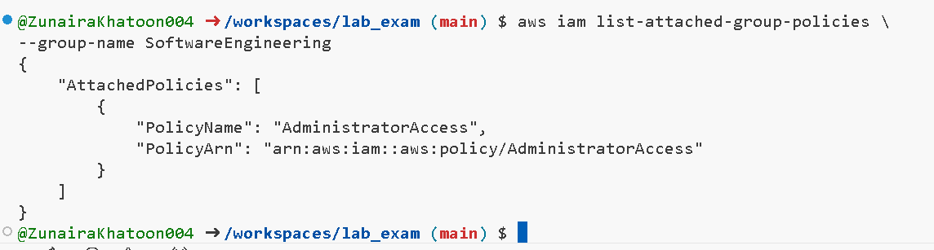
- Verify IAM configuration in AWS Management Console
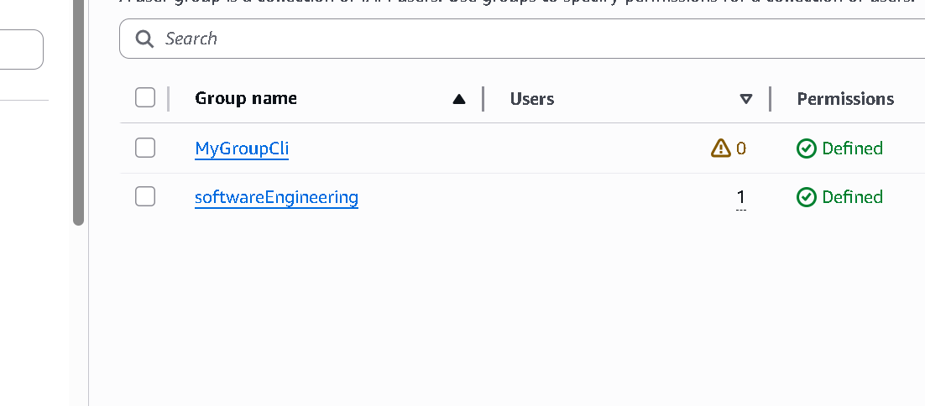
Q2 – Terraform Lab: Simple AWS Environment with Nginx over HTTPS (30 marks)
- Configure the AWS provider
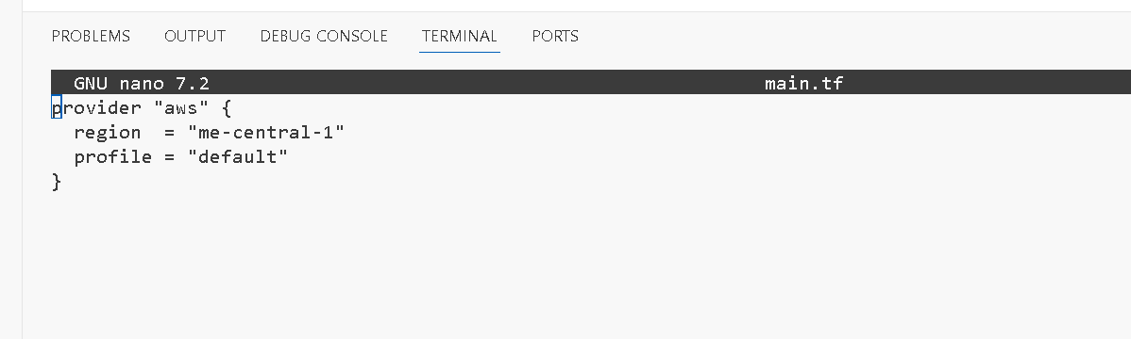
- Define input variables
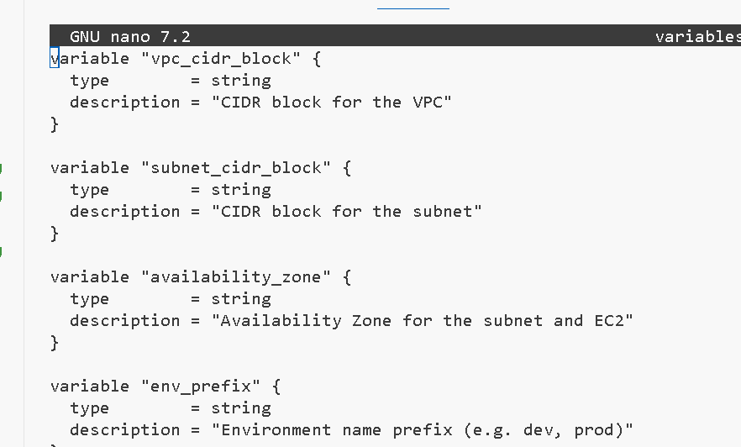
- Create VPC and subnet

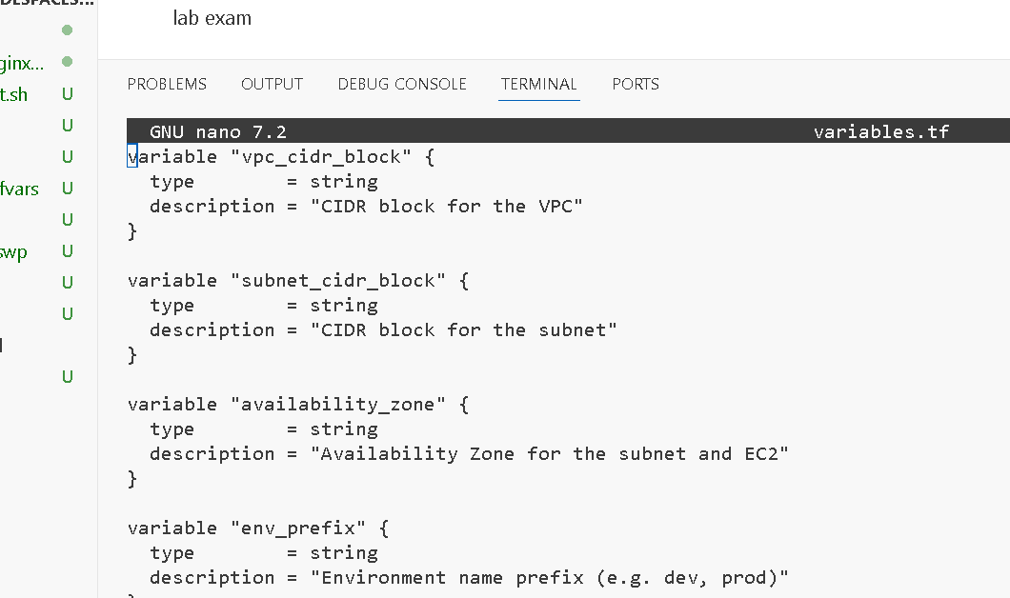
- Create Internet Gateway and configure default route table
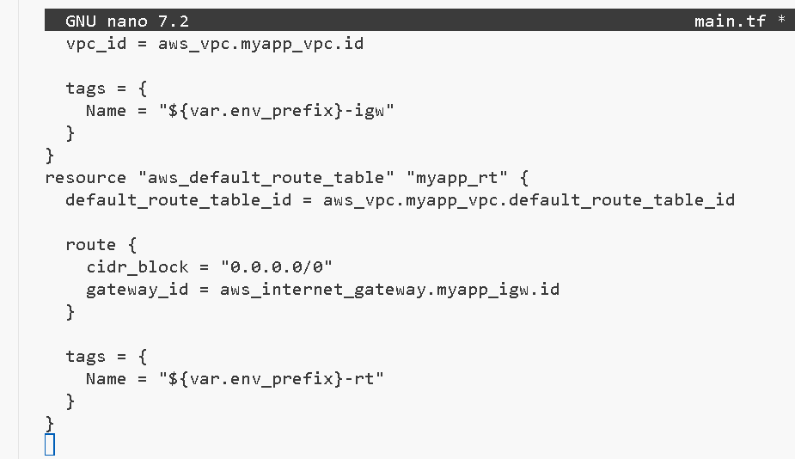
- Discover public IP and compute /32 CIDR using data + locals
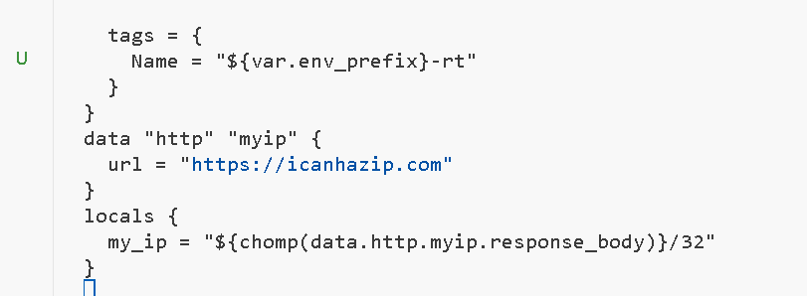
- Configure the default security group in the VPC
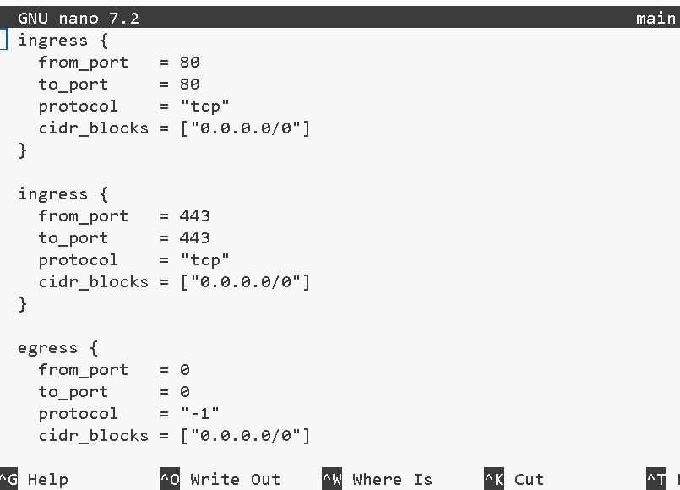
- Create an AWS key pair for SSH
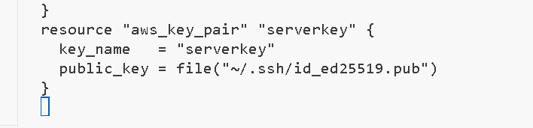
- Create the EC2 instance resource
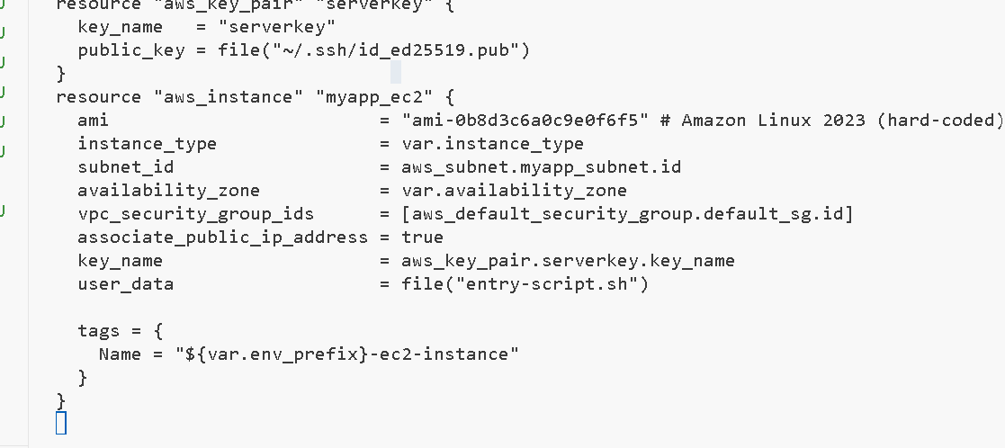
- Create entry-script.sh to configure Nginx + HTTPS
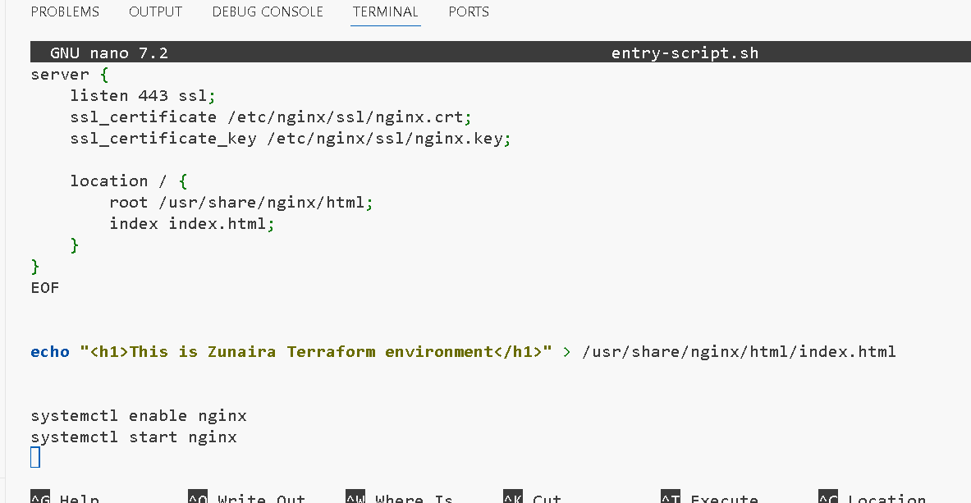
- Add Terraform output for public IP
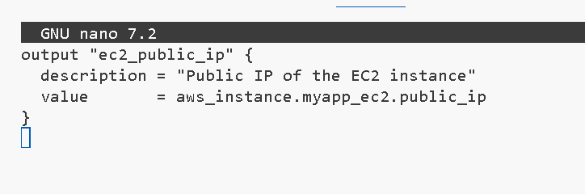
- Set variable values for apply time
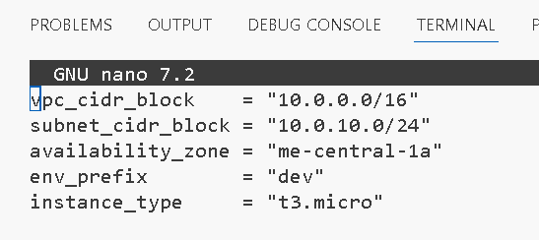
- Run Terraform commands and capture outputs
- Terraform init
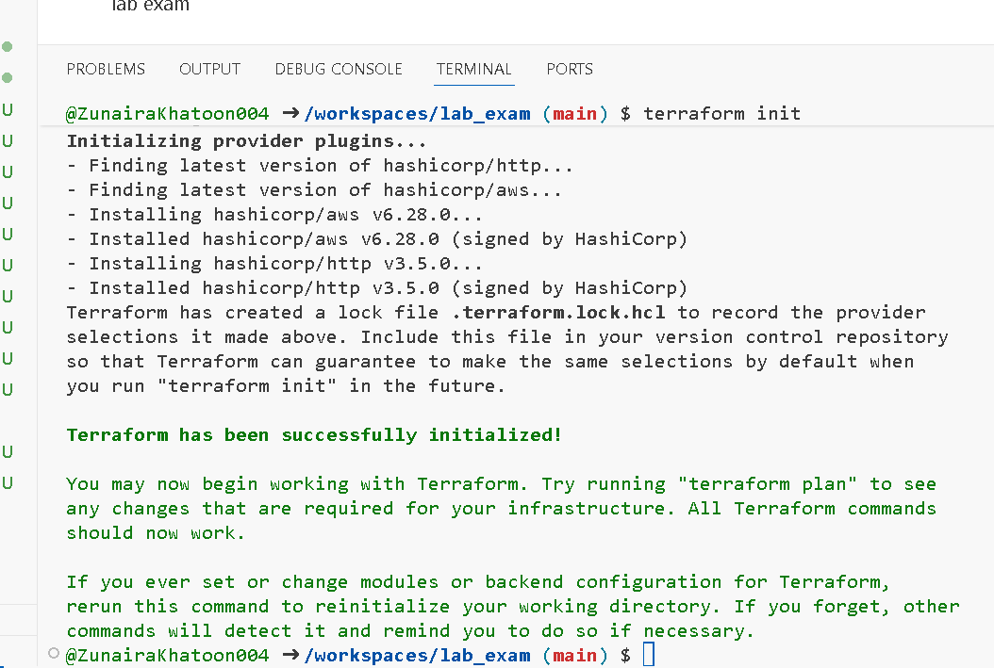
- Terraform plan
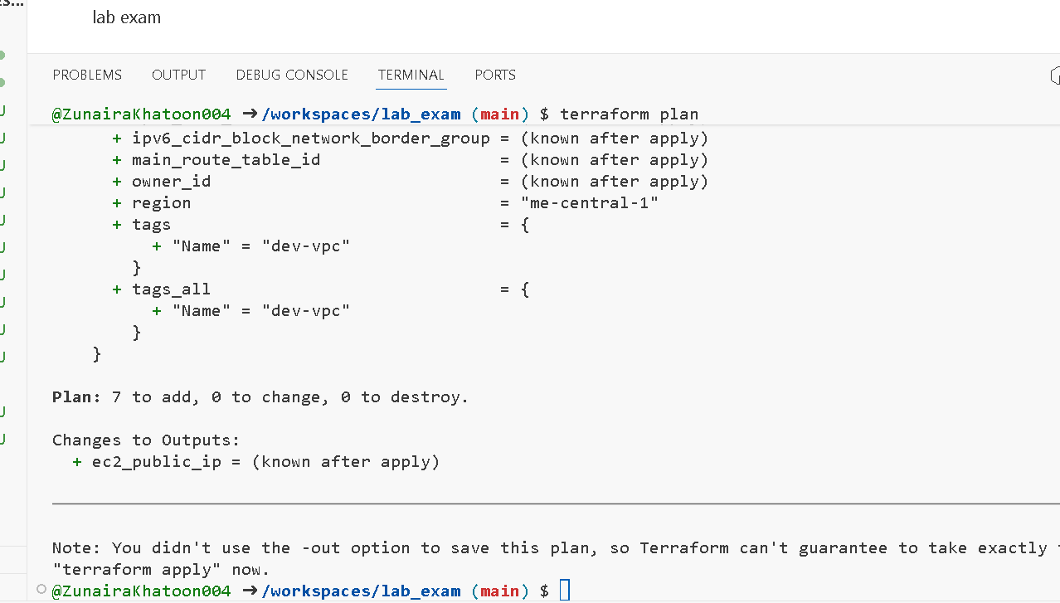
- Terraformapply
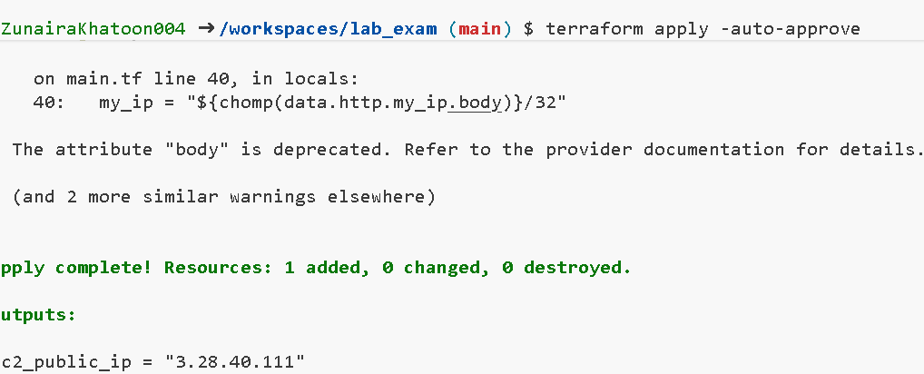
- Terraform output

- Verify Terraform resources in AWS console
VPC and Subnet
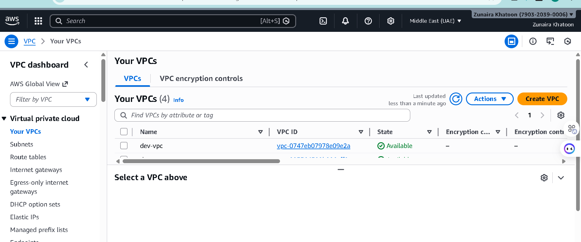
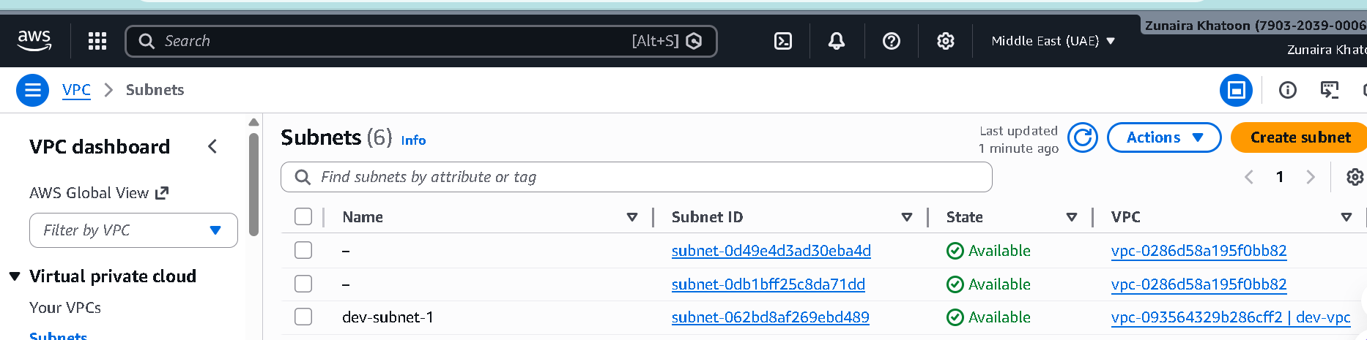
Internet Gateway and Route Table
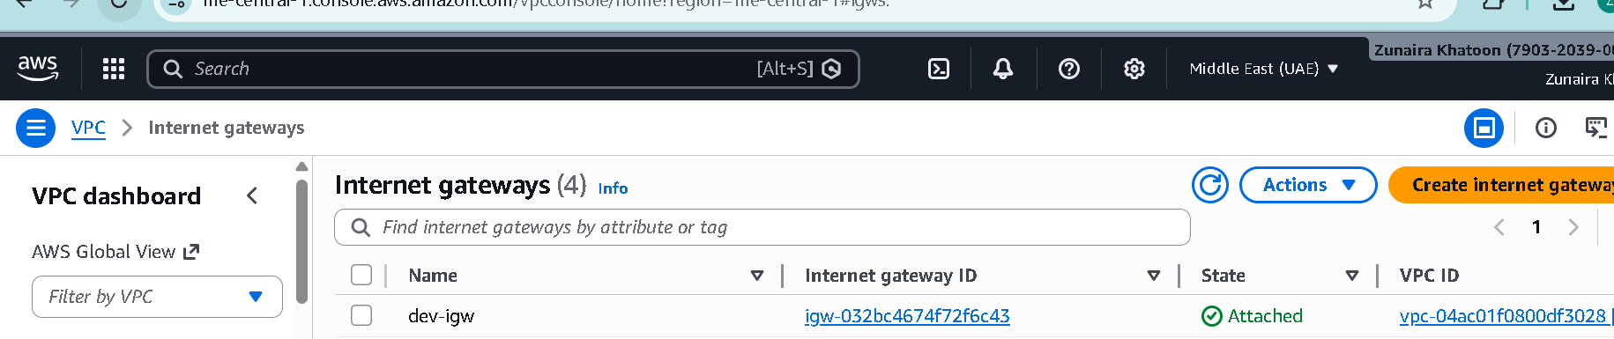
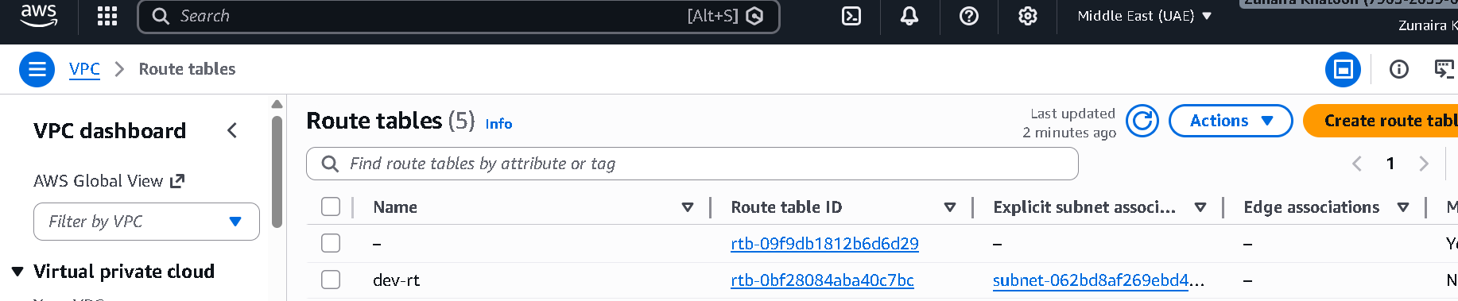
Security Group
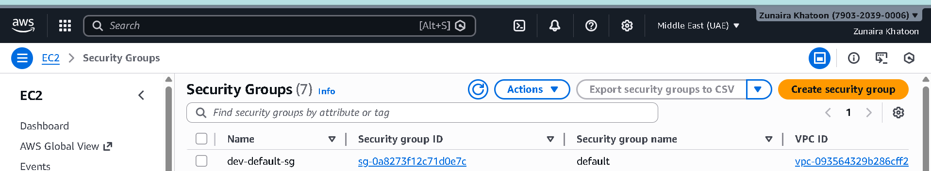
EC2 instance
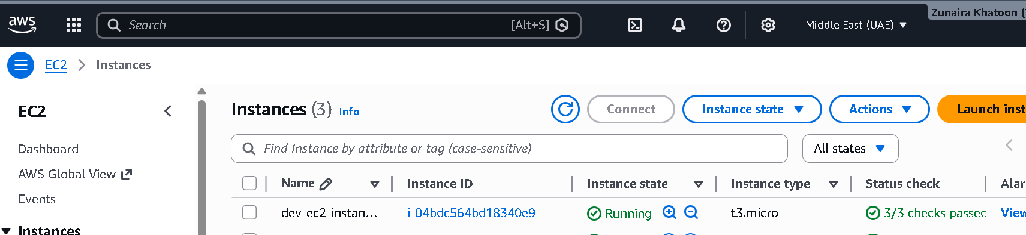
- Verify HTTPS access from browser

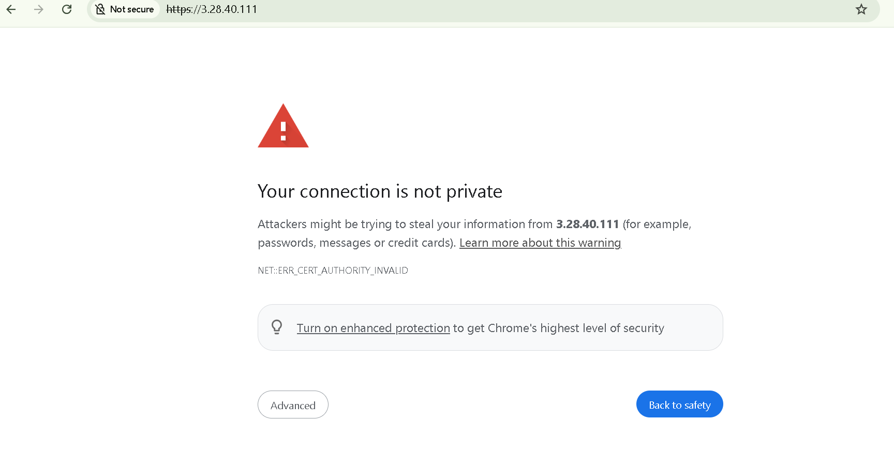
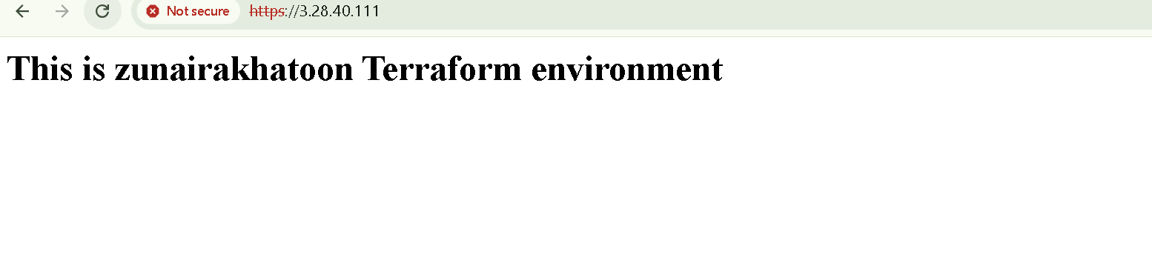
Q3 – Ansible Playbook for EC2 Web Server Using Q2 Instance (10 marks)
- Create Ansible inventory file host
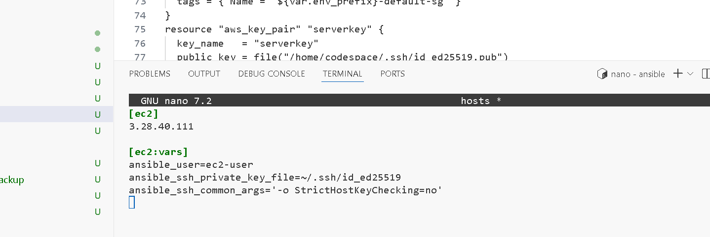
- Create project-level ansible.cfg
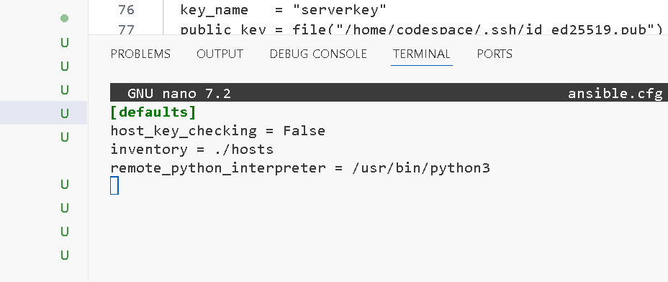
- Create Ansible playbook (e.g. my-playbook.yml)
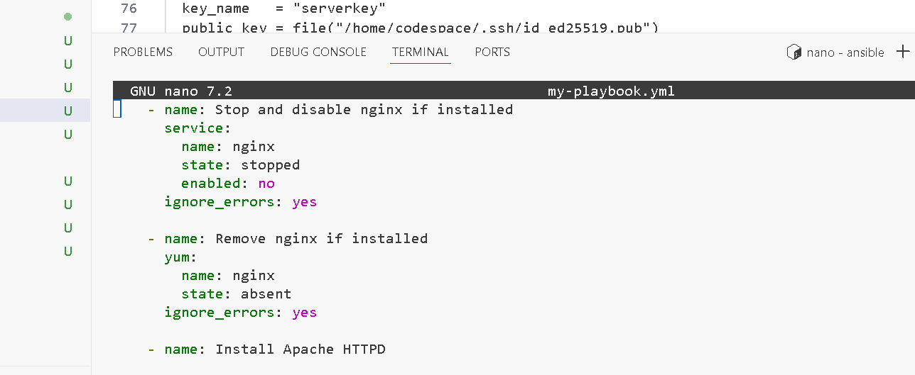
- Run the Ansible playbook
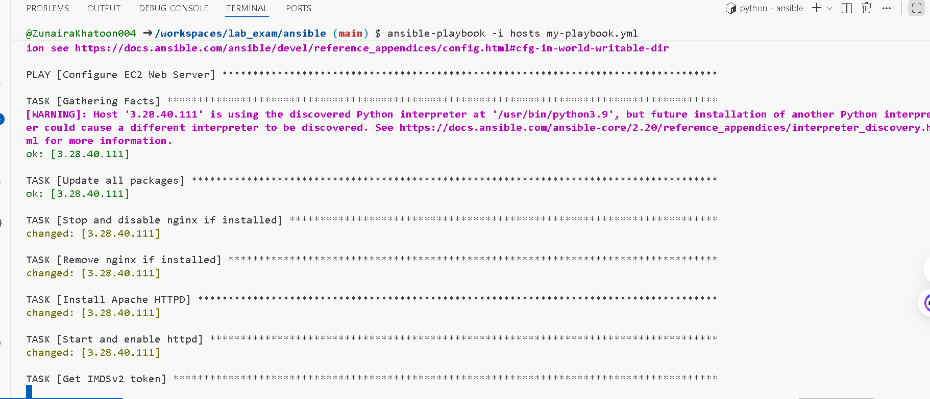
- Verify HTTP access
